Task 01: Create a java program to retrieve dynamodb ttable records and display..

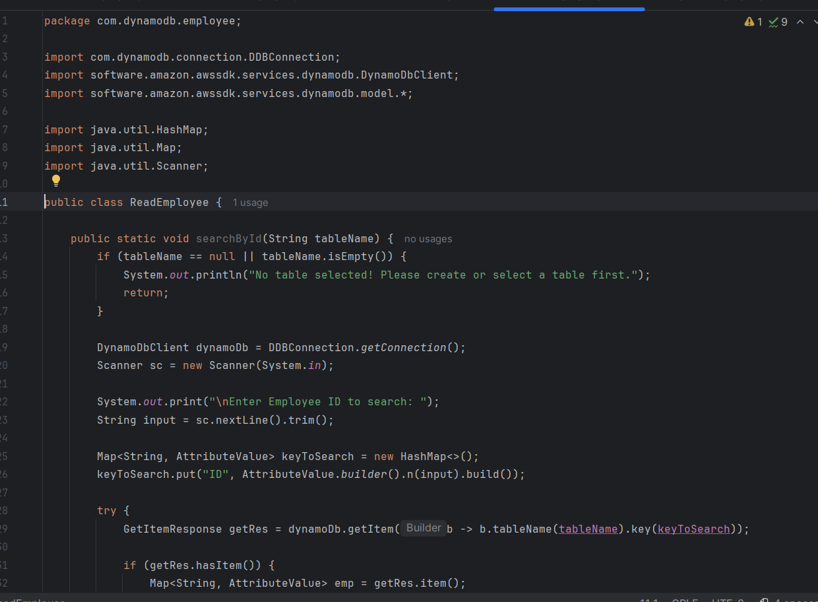

Task 02 : Create a java program to create a table and insert 2 items .. the NOSQl workbench we should be able to see the table updated.

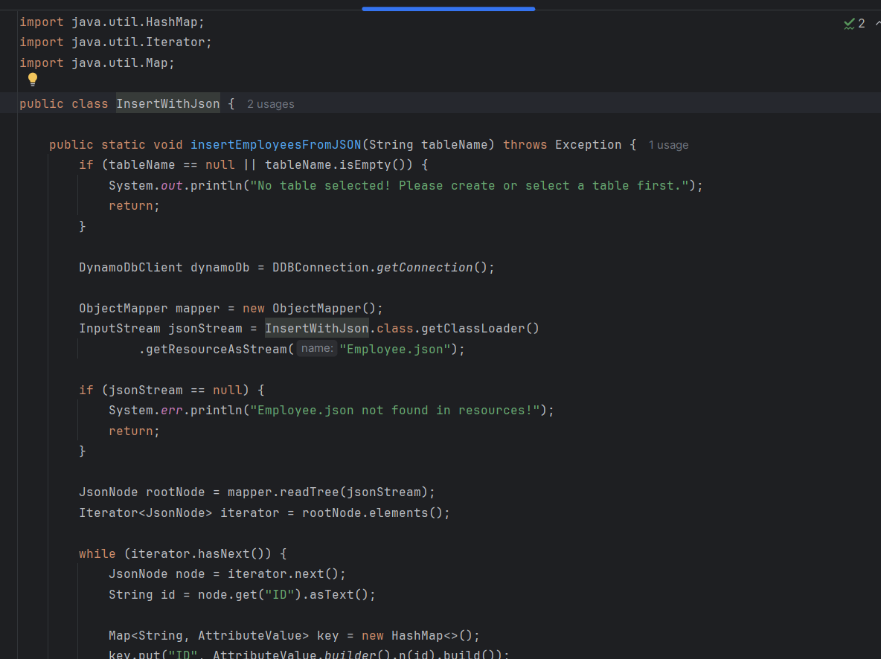

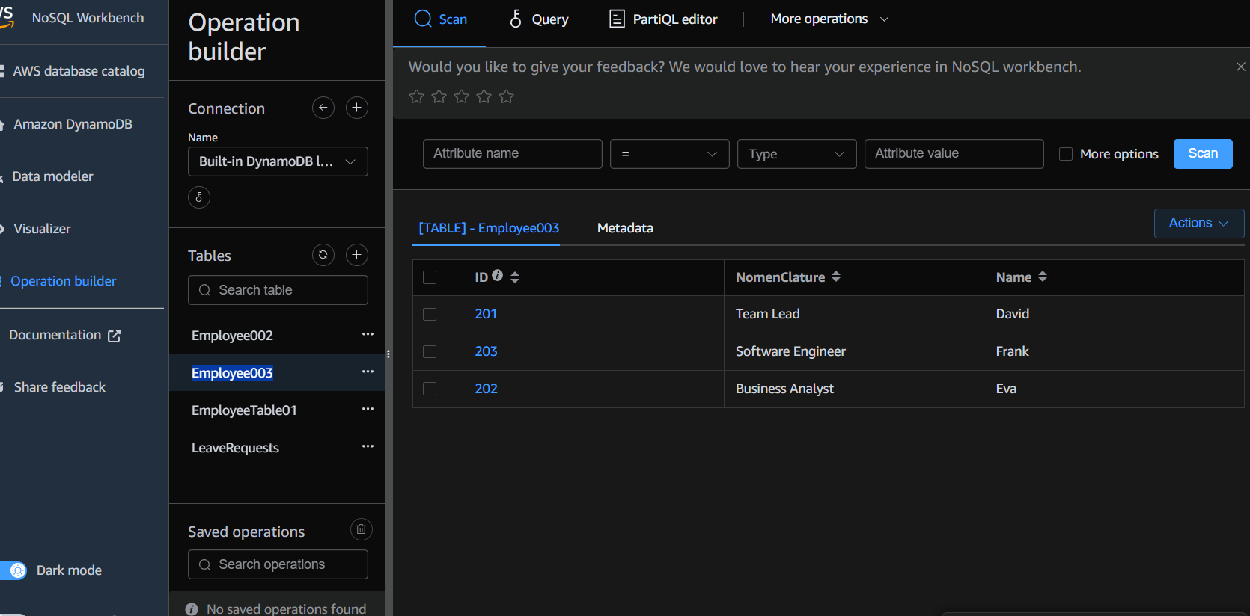

Perfect 👍 I’ll give you clean Q&A format (ignoring time & names).

Task 03: What key features of DynamoDB?
Answer:
- Fully managed NoSQL database (serverless).
- Provides single-digit millisecond latency at any scale.
- Supports key-value and document data models.
- Built-in auto scaling for throughput and storage.
- Highly available and fault-tolerant with replication across multiple AZs.
- Event-driven programming support via DynamoDB Streams.
- Global tables for multi-region replication.
- DAX (DynamoDB Accelerator) for in-memory caching.

Task 04: Advantages and Disadvantages of DynamoDB
Advantages:
- Fully managed → no server maintenance.
- High scalability and performance.
- Flexible schema (schema-less).
- Integration with AWS ecosystem.
- Auto-scaling and on-demand pricing.
Disadvantages:
- Expensive for very high workloads.
- Querying is limited (no complex joins/aggregates).
- Requires careful design of partition/sort keys.
- Learning curve compared to SQL databases.

Task 05: Use Cases of DynamoDB
- E-commerce apps (catalogs, orders, shopping carts).
- Gaming leaderboards and session tracking.
- IoT data storage with fast writes/reads.
- Banking/Financial transactions (atomic operations).
- Content management systems.
- Mobile and web apps requiring low-latency data access.

Task 06: What is DynamoDBMapper?
Answer:
- A Java object persistence model provided by AWS SDK.
- Maps Java classes (POJOs) to DynamoDB tables.
- Helps developers use annotations (@DynamoDBTable, @DynamoDBHashKey, @DynamoDBAttribute) instead of writing raw queries.
- Provides simple save(), load(), query(), scan() methods.

Task 07: What are DynamoDB Projections?
Answer:
- Projections define which attributes are copied to a secondary index.
- Types of Projections:
  - KEYS_ONLY → Only partition & sort keys.
  - INCLUDE → Keys + selected attributes.
  - ALL → All attributes from the table.

Task 08: How does DynamoDB prevent data loss?
Answer:
- Stores data across 3 Availability Zones automatically.
- Point-in-Time Recovery (PITR) for backup/restore.
- On-demand backups.
- Streams help recover from accidental changes.
- Strong consistency option prevents stale reads.

Task 09: What are In-place Atomic Updates? Does DynamoDB support them?
Answer:
- In-place atomic update → Modify only part of an item (not rewrite whole item).
- DynamoDB supports atomic updates using:
  - UpdateItem API.
  - Atomic counters (ADD operation).
  - Conditional writes to ensure no conflicts.

Task 10: What are Streams in DynamoDB?
Answer:
- DynamoDB Streams capture real-time changes in a table (insert, update, delete).
- Each change is recorded as an event.
- Used for replication, event-driven triggers (via Lambda), and analytics pipelines.

Task 11: What are DynamoDB Pricing Tiers?
Answer:
- On-Demand Capacity → Pay per request (no need to specify throughput).
- Provisioned Capacity → Pre-allocate Read/Write Capacity Units (RCUs/WCUs).
- Free Tier → 25 GB storage + 25 RCU/WCU for 12 months.
- Pricing also for:
  - Storage (per GB).
  - Streams.
  - Global tables.
  - DAX caching.
  - Backup & restore.

Task 12: Max Item Size in DynamoDB
Answer:
- 400 KB per item (including attribute names + values).

Task 13: Max Global Secondary Indexes (GSI)
Answer:
- You can create up to 20 GSIs per table.

Task 14: What is DynamoDB Accelerator (DAX)?
Answer:
- In-memory caching layer for DynamoDB.
- Provides microsecond response times.
- Reduces read latency for high-traffic apps.
- Fully managed and compatible with DynamoDB APIs.

Task 15: What are DynamoDB Global Tables?
Answer:
- Multi-region, multi-master replication.
- Automatically replicates tables across AWS regions.
- Useful for disaster recovery and global apps.
- All regions can accept read/write operations.

Task 16: What are Indexes and Secondary Indexes?
Answer:
- Index = An alternate way to query a table.
- Local Secondary Index (LSI):
  - Same partition key as table but different sort key.
  - Up to 5 LSIs per table.
- Global Secondary Index (GSI):
  - Different partition and sort key from the table.
  - Up to 20 GSIs per table.

Task 17: What are Hot Keys and Hot Partitions?
Answer:
- Hot Key → A single partition key that receives a disproportionate number of requests.
- Hot Partition → A partition storing multiple hot keys, causing throttling.
- Best Practice → Distribute workload evenly with randomization techniques.

Task 18: Table-level vs Item-level Operations
Table-level operations:
- CreateTable
- DescribeTable
- UpdateTable
- DeleteTable
- ListTables
Item-level operations:
- PutItem
- GetItem
- UpdateItem
- DeleteItem
- Query
- Scan

